
China Economic Activity February 2026
16-Mar-26
China: Economic activity readings beat expectations
Latest reading: China’s industrial production increased by 6.3% year over year in the combined January–February period of 2026, accelerating from 5.2% growth in December and surpassing market expectations. Growth strengthened across major sectors, including mining, manufacturing, and utilities.
Retail sales increased by 2.8% year on year in the first two months of 2026, up from a 0.9% rise in December and above market expectations. This represents the strongest growth since last October.
Fixed-asset investment rose by 1.8% in January–February 2026, surprising on the upside as markets had expected a decline. The increase comes after a 3.8% contraction in 2025—the first annual drop since 1989—driven largely by the property sector slump and tighter limits on local government borrowing. Early in 2026, strong gains in infrastructure investment and a moderate rise in manufacturing spending more than compensated for the continued sharp fall in property investment. House prices and construction activity also remained weak at the outset of 2026.
Panelist insight: On the data, Nomura analysts said:
“Despite the rebound, we do not think China’s economy has recovered, as these data might have been driven by factors that are not sustainable, the special timing of the Chinese New Year holiday and the delayed payback impact of the trade-in program. We expect major activity indicators to decline over the next few months.”
ING’s Lynn Song said:
“Our first data dump of the year showed indicators beating forecasts across the board, largely due to downbeat expectations rather than a particularly robust domestic economy. After the significant beat in trade data to start 2026, the same theme from the last two years remains in play, where a resilient external environment helps offset relatively slower domestic growth.”
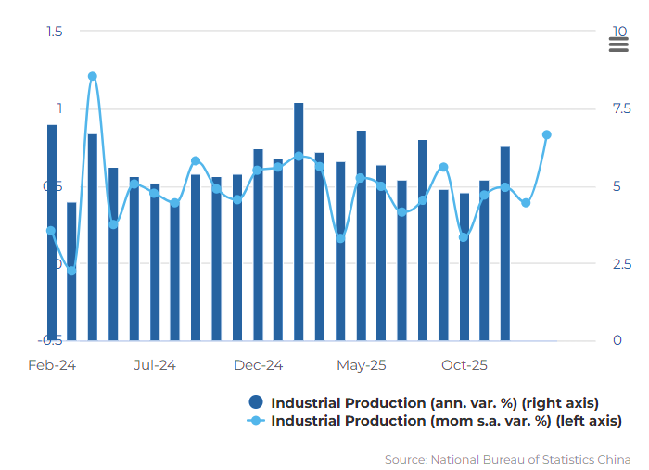https://www.focus-economics.com/countries/china/news/economic-activity/china-economic-activity-16-03-2026-economic-activity-readings-beat-expectations/

Using the data provided, identify the most relevant PESTLE factors influencing China’s economic activity. Which elements are dominant, and which are negligible? Justify your answer with evidence.
Political
Economic
Social
Technological
Legal
Environmental

